**PROJECT REPORT**

**1.INTRODUCTION:**

**1.1 OVERVIEW:**

These exploration-focused YouTube channels offer a diverse range of content, from remote and exotic travel to urban exploration and in-depth cultural encounters. They not only inspire wanderlust but also promote understanding and appreciation for the diversity of our planet and its people. Whether you're seeking adventure, cultural insights, or just a virtual escape, these channels have something to offer for every explorer at heart.

**1.2 PURPOSE:**

It's important to note that the purpose of a top YouTube channel may evolve over time as the creator's interests, goals, and audience change. Successful channels often combine elements of several of these purposes to provide a well-rounded and engaging viewing experience for their audience.

Top of Form

**2. PROBLEM DEFINITION & DESIGN THINKING:**

**2.1 Empathy Map:**

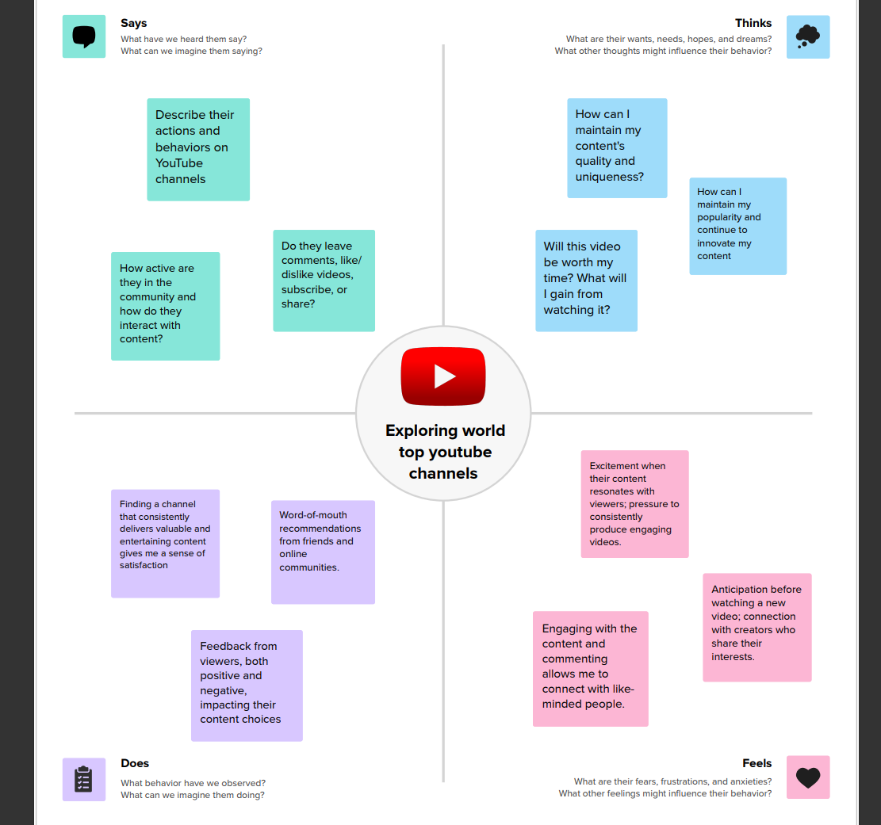

**2.2 IDEATION AND BRAINSTORMING MAP:**

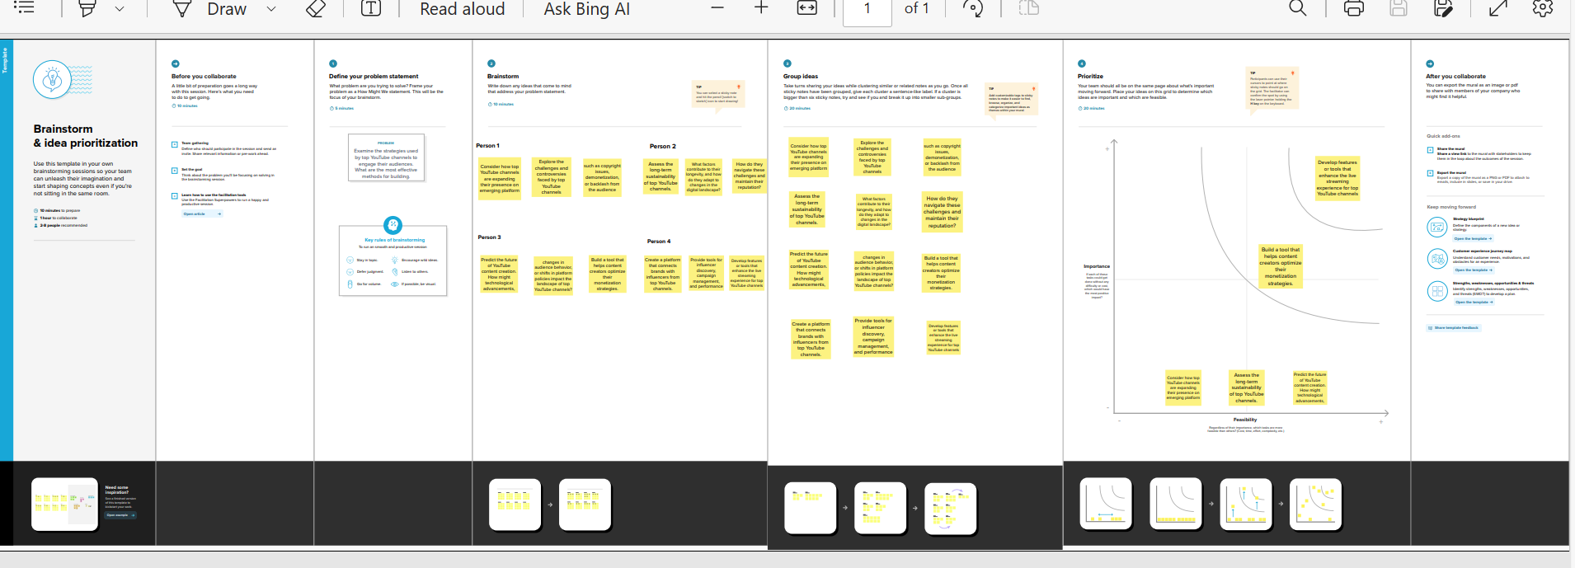

**3. RESULT:**

**DASHBOARD:**

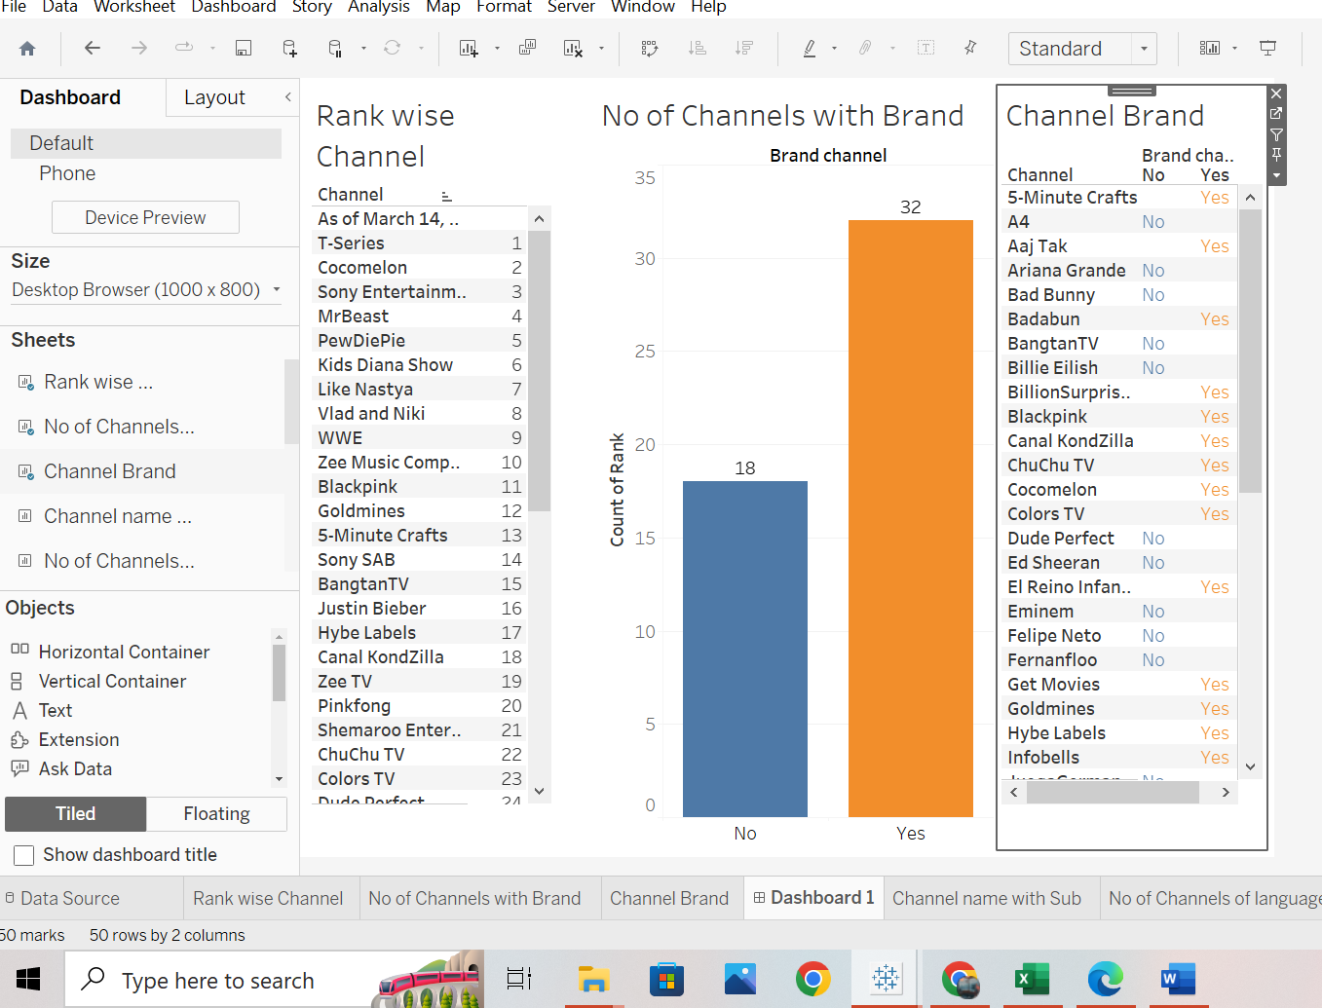

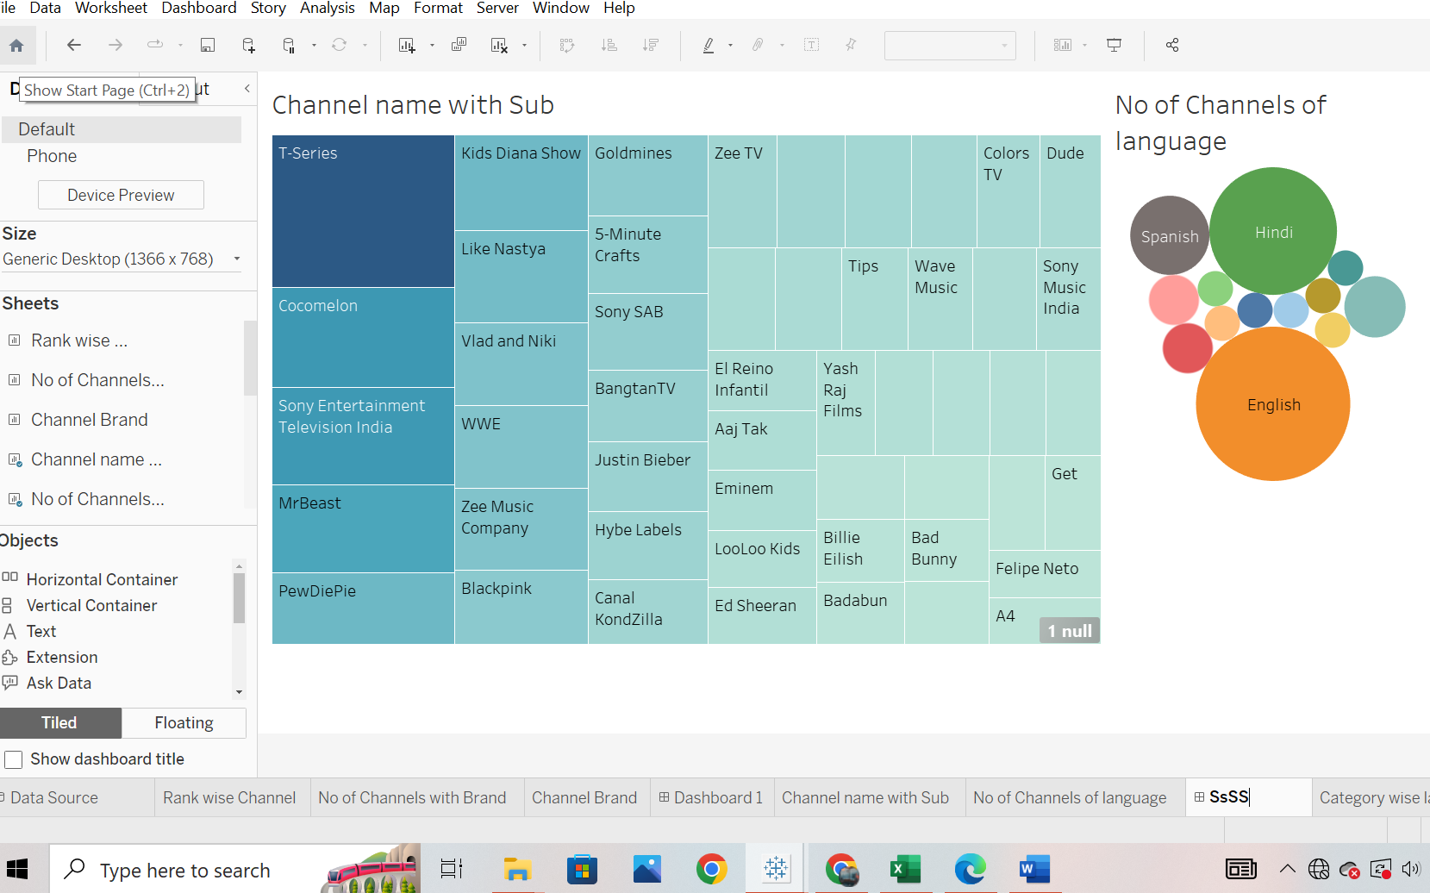

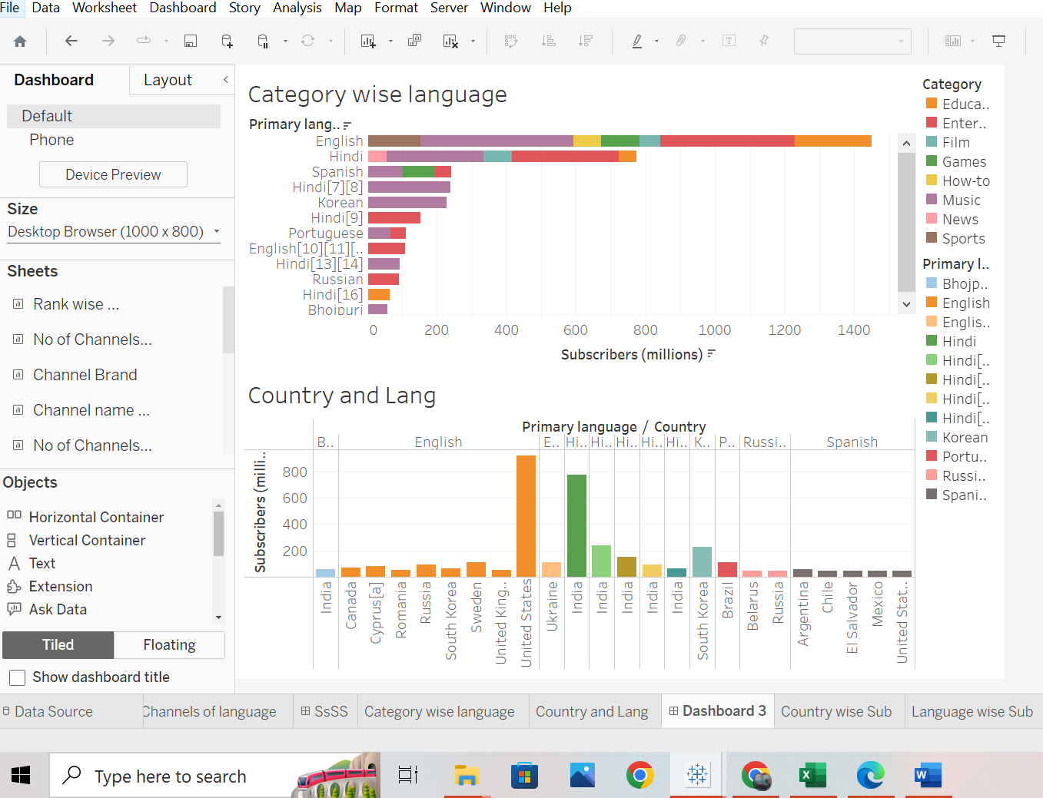

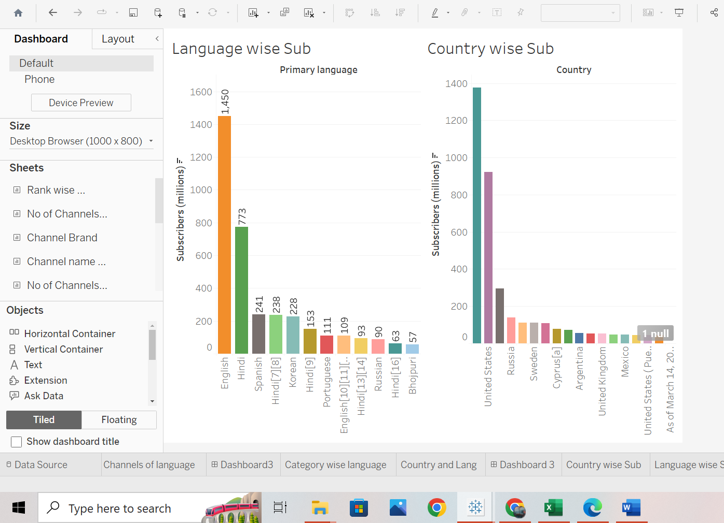

**STORY:**

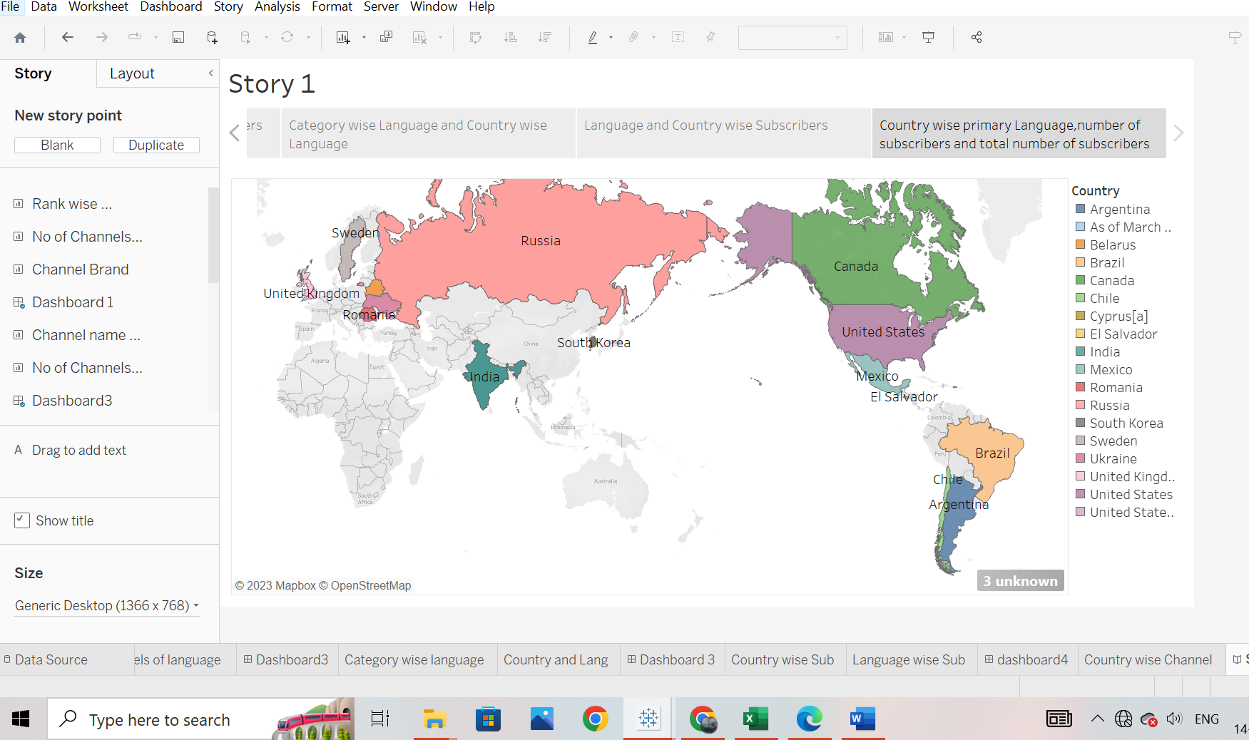

**4. ADVANTAGES AND DISADVANTAGES:**

**Advantages:**

1. **Entertainment**: Many YouTube channels are primarily created for entertainment purposes. They produce content that is meant to be enjoyable, funny, or engaging, providing viewers with a source of amusement and relaxation.
2. **Education**: Some YouTube channels are dedicated to educating their audience. They create content that imparts knowledge, skills, or insights on a wide range of topics, from science and history to cooking and DIY project
3. **Inspiration**: Top YouTube channels can inspire viewers through motivational content, success stories, personal growth, and self-improvement. They may share their own experiences to encourage others to pursue their goals and dreams.
4. **Exploration and Travel**: As mentioned in the previous response, some YouTube channels focus on exploration and travel. Their purpose is to take viewers on virtual adventures, allowing them to experience new cultures, places, and experiences from the comfort of their screens.

**Disadvantages:**

1. **Privacy Concerns**: As channels become more popular, content creators might face privacy invasion, with viewers prying into their personal lives and sometimes even stalking them.
2. **Dependency on Algorithms**: YouTube's algorithm changes can significantly impact a channel's viewership and income. Creators may find it challenging to adapt to these shifts.
3. **Copyright Issues**: Top channels often deal with copyright claims and disputes, as their content can be subject to stricter scrutiny.
4. **Pressure to Monetize**: Successful channels may feel compelled to focus more on monetization through ads, sponsorships, and merchandise, potentially compromising the authenticity of their content.
5. **Stagnation**: Some channels risk becoming stagnant or repetitive, as creators continue to produce content solely to maintain their popularity, rather than pursuing their true interests.
6. **APPLICATION:**
7. **Choose Your Niche**: Select a niche or topic for your YouTube channel. It's essential to choose something you're passionate about and have expertise in. Popular niches include travel, beauty, gaming, lifestyle, technology, and many more.
8. **Market Research**: Research your chosen niche to identify potential competitors, target audience demographics, and content trends. This will help you understand what's already out there and how you can differentiate your channel.
9. **Content Strategy**: Develop a content strategy. Decide what types of videos you'll create, how often you'll upload, and what unique angle or approach you'll take in your content.
10. **Equipment and Setup**: Invest in the necessary equipment, such as a good camera, microphone, and video editing software. Create a dedicated space for filming and ensure good lighting and sound quality.

**6. CONCLUSION:**

'the success of a YouTube channel largely depends on several factors such as niche selection, high-quality content creation, audience engagement, and consistent effort. Whether you aspire to create a top YouTube channel or you're a viewer seeking valuable content, understanding these elements is crucial.

For content creators, choosing a niche that aligns with your interests and expertise is the first step. In a competitive landscape, conducting market research and offering a unique perspective or approach is essential. High-quality content, combined with excellent production values, can set your channel apart. Building a dedicated audience requires engagement, community-building, and effective promotion. Over time, as your channel grows, exploring monetization options and adapting to audience feedback are important for long-term success.

Top of Form**FUTURE SCOPE:**

**Diversification of Content**: YouTube has expanded beyond traditional vlogs and entertainment. The future will likely see an even wider variety of content, including educational channels, niche interest channels, and hybrid formats that blend entertainment with information.